All Pakistan Trade Union Federation

All Pakistan Trade Union Federation/Railway Workers Union oppose privatization of Pakistan Railways: demand end of political interference

.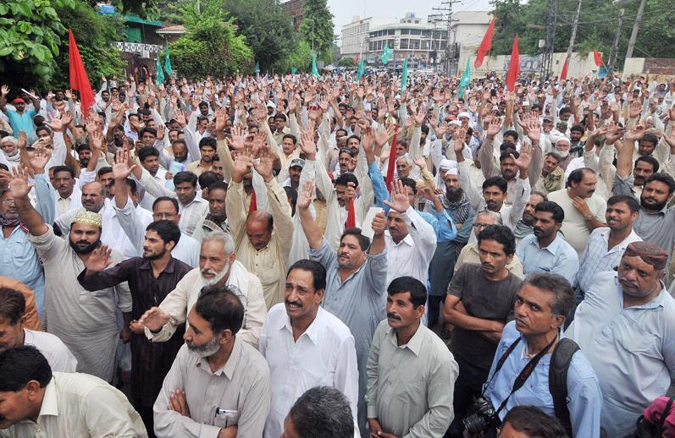
Under the banner of All Pakistan Trade Union Federation, a protest agitation was held against the privatization of Pakistan Railway.
Leaders of All Pakistan Trade Pakistan Trade Union Federation and the key trade unions of Pakistan Railways PR while opposing the privatization of the organization have demanded restructuring of its management by inducting professional managers: providing funds for repair and purchase of locomotive and making railway profitable through transportation of cargo in the country.
While speaking Rubina Jamil, General Secretary APTUF, Anwar Gujjar, President APTUF, Nasir Gulzar, Mian Khalid, President Railway Workers Union, Mustanser Javed, GS said that the political interference in the affairs of Pakistan Railway: lack of accountability and uncontrolled corruption by bureaucracy as the major factors of the downslide of the railways: which is an important organization of the country: providing transportation services to millions of people and direct employment of hundreds of thousands of people.
Speakers said that Railway is a national asset and it should be made profitable. The PR can easily become profitable if the corruption is plugged in and its assets are properly utilized: they commented.
In their recommendation speakers rejected the idea of privatization or dividing PR into various components. They suggested introducing changes in Railways Act according to needs of time. The Act was enacted in 1890 and needs revision through parliament. Trade Unions should be given representation at the board and management levels. New legislation should be made according to ILO conventions and new laws are made to make PR a commercially viable organization.

The workers representatives termed the Railway Police as a burden on the organization and a cause of the rampant corruption and financial losses. They demanded to abolish Railway Police and introduce the old Watch and Ward system. They also recommended separating the pensions from the budget of PR as is being done for the military employees.
They suggested that appointment of professionals at the management level. They criticized the role of private sector in Pakistan Railway: who has caused financial losses to the organization on many occasions in the past. They said Business Train and Shalimar Express trains were recently handed over to the private companies but these companies have become defaulters as they have filed to deposit the committed amounts in the PR accounts.
The speakers said Pakistan Railways has acquired workshops and others facilities as well as trained manpower for manufacturing and overhauling of engines: making coaches: sleepers and tracks: which should be utilized to make it profitable. They criticized the military governments in the past: who caused financial losses to the PR. For example: they mentioned that General Zia Government established the National Logistic Cell NLC and the entire cargo handling were handed over to it: which reduced the cargo traffic through rail. Similarly: during General Pervaiz Musharraf’s military government: then Railway Minister who was a retired military general: purchased Chinese engines and coaches: which developed faults within two years and majority of them are non-functional. Even the 30 year old engines imported from the USA and Europe are still in operation.

